Project Design Phase-II
Technology Stack (Architecture & Stack)

Date | 31 January 2025
Team ID | Not specified in project brief
Project Name | Auto Ticket Classification using Flow Designer
Maximum Marks | 4 Marks

Technical Architecture: ServiceNow School IT Ticket Automation
The architecture uses the ServiceNow platform, a custom Incident Workflow table, Flow Designer conditions, reference and choice fields, and email notification. The design is no-code, maintainable, and suited to a school helpdesk.
Project architecture: automated ticket classification and notification
Source: Auto Ticket Classification using Flow Designer project brief
Guidelines:
Include all the processes (As an application logic / Technology Block)
Provide infrastructural demarcation (Local / Cloud)
Indicate external interfaces (third party API’s etc.)
Indicate Data Storage components / services
Indicate interface to machine learning models (if applicable)
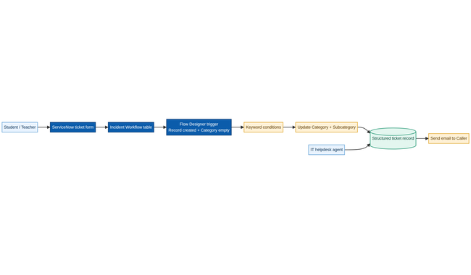

Table-1: Components & Technologies
S.No | Component | Description | Technology
1 | User Interface | Form used by students and teachers to submit Caller and Short Description. | ServiceNow record form
2 | Application Logic-1 | Trigger flow when a record is created and Category is empty. | ServiceNow Flow Designer
3 | Application Logic-2 | Evaluate Wi-Fi, Projector, Password/Login, and Slow/Hanging keywords. | Flow Designer If / Else If conditions
4 | Application Logic-3 | Update Category and Subcategory and send the caller confirmation. | Flow Designer Update Record + Send Email
5 | Database | Store auto-number, Caller, choices, descriptions, state, and assignment data. | Incident Workflow custom table
6 | Cloud Database | Platform-managed persistence for ticket records and reference data. | ServiceNow platform data store
7 | File Storage | Store the Project Update Set XML export for deployment and reuse. | ServiceNow Update Set / XML export
8 | External API-1 | No external API is required for core classification. | None
9 | External API-2 | Caller notification uses the platform email action. | ServiceNow email notification
10 | Machine Learning Model | Not required; classification is deterministic keyword logic. | None — no-code rules
11 | Infrastructure (Server / Cloud) | Hosted enterprise service platform for forms, data, flows, and email. | ServiceNow instance

Table-2: Application Characteristics
S.No | Characteristics | Description | Technology
1 | Open-Source Frameworks | No external framework is required for the no-code implementation. | ServiceNow platform configuration
2 | Security Implementations | Role-based access, controlled configuration access, and authorized record updates. | ServiceNow roles and ACLs
3 | Scalable Architecture | Standardized fields, reusable flow conditions, and update sets support adding new issue types. | Flow Designer + Update Sets
4 | Availability | Hosted platform services support the school helpdesk during operating hours. | ServiceNow instance availability
5 | Performance | Classification occurs at record creation using lightweight keyword checks and direct field updates. | Flow Designer conditions

References:
Source project: Auto Ticket Classification using Flow Designer
Source project: Auto Ticket Classification using Flow Designer
Source project: Auto Ticket Classification using Flow Designer
Source project: Auto Ticket Classification using Flow Designer
Source project: Auto Ticket Classification using Flow Designer

